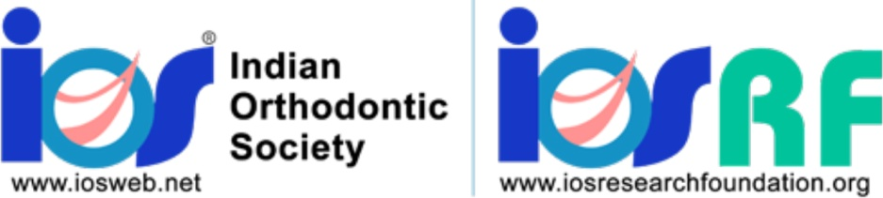

**Preliminary application for Research Grants for the year 2023**

**LIFE MEMBER RESEARCH GRANT**

**PRINCIPAL APPLICANT DETAILS**

Name:

Life Membership No:

Designation:

Institutional Affiliation:

Contact Address (including email and phone numbers):

**CO-INVESTIGATOR/S DETAILS (Must be presented in the following format)**

Name:

1OS LM:

Designation:

Institutional Affiliation:

Contact Address (including email and phone numbers):

Please include a brief CV of the principal investigator and co-investigators not more than 2

pages including a list of not more than 5 recent research (not review) articles published along

with this application



**PROJECT DESCRIPTION**

Please fill out the following sections for your proposed Indian Orthodontic Society Research

Foundation (1OS-RF) project. Note that there are word limit restrictions for each section, and these

limits should be strictly adhered to. The project description should be written so that readers

without technical expertise can understand.

**a. Project title (limit 25 words)**

**b. Summary of research (limit 300 words)**

**c Aims and objectives (limit 200 words)**

**d. Significance of the research and focus area (1000 words)**

**e. Current stage of the project (if already initiated the research)**

**f. Milestones and key objectives to be achieved (please outline within a three-year time**

**period)**

**g. Possibility of obtaining patent**

**h. Academic or clinical impact on the field of Orthodontics (100 words)**

**i. Single or multiple institution projects (if multiple institution project, please list all**

**institutions involved)**

**j. Any other relevant background information (limit 100 words)**

**k. Budget**

Please provide the estimated total budget figure for your proposed project. Proposed projects may

be **up to three years** for life members. (unless noted under specific focus area)A detailed budget

will not be required at this time but should be submitted if the project is shortlisted for final

application.