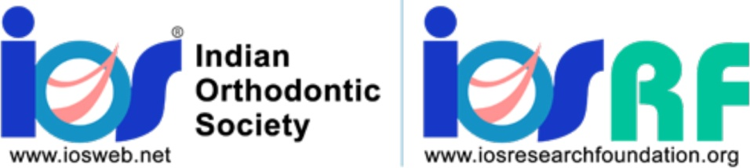

**Preliminary application for Research Grants for the year 2023**

**Application for Student Life Member Research Grant**

**PRINCIPAL APPLICANT DETAILS**

Name:

SLM number:

Year of Joining MDS:

Year of Study:

Name of Institution

Contact Address (including email and phone numbers):

**MENTOR/GUIDE DETAILS (Must be presented in the following format)**

Name:

IOS LM number:

Designation:

Institutional Affiliation:

Contact Address (including email and phone numbers):

Please include a brief CV of the principal investigator and mentors/guides (not more than2 pages) including a listing of not more than 5 recent research not review) articles published along with this application.

**PROJECT DESCRIPTION**

Please fill out all sections for your proposed Indian Orthodontic Society Research Foundation IOS-RF) project. Note that there are word limit restrictions for each section, and these limitsshould be strictly adhered too. The project description should be written so that readers without technical expertise can understand.

**a. Project title (limit 25 words)**

**b. Summary of research (limit 300 words)**

**c. Aims and objectives (limit 200 words)**

**d. Significance of the research and focus area (1000 words)**

**e. Current stage of the project (if already initiated the research)**

**f. Milestones and key objectives to be achieved (please outline within a two-year time**

**period)**

**g. Possibility of obtaining patent**

**h. Academic or clinical impact on the field of Orthodontics (100 words)**

**i. Single or multiple institution projects (if multiple institution project, please list all**

**institutions involved)**

**j. Any other relevant background information (limit 100 words)**

**k. Budget**

Please provide the estimated total budget figure for your proposed project. Proposed project shall be up to two years for student life members. A detailed budget will not be required at this time but should be submitted if the project is shortlisted for final application.

A two-year contract with 1OS-RF and an affidavit in Rs.100/stamp paper stating that the proposed research will be completed before the student life member completes his/her postgraduate program signed by the awardee and countersigned by a guarantor - Guide /HOD of the respective department of orthodontics is mandatory. The guarantor-Guide /HOD will undertake the fiscal responsibility if the student is unable to complete the project and submit a report in the stipulatedtime.